**[Sum Root to Leaf Numbers](https://leetcode.com/problems/sum-root-to-leaf-numbers/)**

You are given the root of a binary tree containing digits from 0 to 9 only.

Each root-to-leaf path in the tree represents a number.

* For example, the root-to-leaf path 1 -> 2 -> 3 represents the number 123.

Return *the total sum of all root-to-leaf numbers*. Test cases are generated so that the answer will fit in a **32-bit** integer.

A **leaf** node is a node with no children.

**Example 1:**

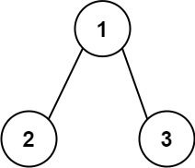

**Input:** root = [1,2,3]

**Output:** 25

**Explanation:**

The root-to-leaf path 1->2 represents the number 12.

The root-to-leaf path 1->3 represents the number 13.

Therefore, sum = 12 + 13 = 25.

**Example 2:**

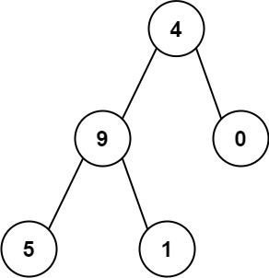

**Input:** root = [4,9,0,5,1]

**Output:** 1026

**Explanation:**

The root-to-leaf path 4->9->5 represents the number 495.

The root-to-leaf path 4->9->1 represents the number 491.

The root-to-leaf path 4->0 represents the number 40.

Therefore, sum = 495 + 491 + 40 = 1026.

**Constraints:**

* The number of nodes in the tree is in the range [1, 1000].
* 0 <= Node.val <= 9
* The depth of the tree will not exceed 10.

class Solution {

public:

int sumNumbers(TreeNode* root) {

return dfs(root, 0);

}

int dfs(TreeNode* node, int pathSum) {

if (!node)

return 0;

pathSum = pathSum * 10 + node->val;

if (!node->left && !node->right)

return pathSum;

return dfs(node->left, pathSum) + dfs(node->right, pathSum);

}

};

Link : <https://leetcode.com/problems/sum-root-to-leaf-numbers/submissions/1232996533/?envType=daily-question&envId=2024-04-15>